AWS Task-4

**Task Description:**

Launch an EC2 instance (Linux and Windows) along with a web server. Then, create an EBS volume of 5 GB, attach it to an EC2 machine (Linux and Windows), and take a snapshot. Finally, create an EBS volume using the taken snapshot.  
  
**Screenshot 1: Linux EC2 Instance Running**

This screenshot shows the successful launch of a Linux EC2 instance.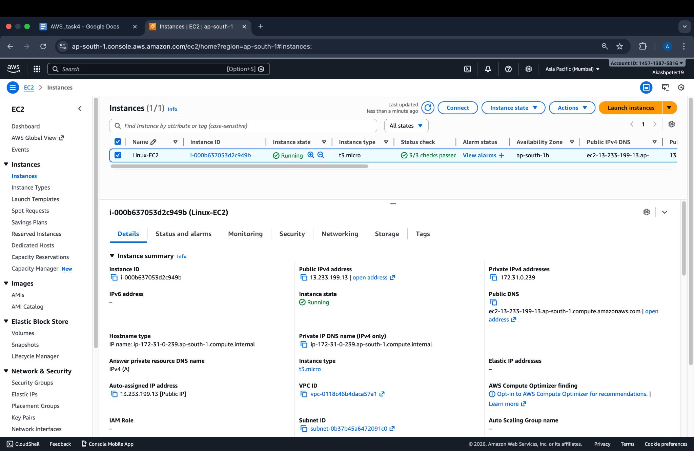

### **Screenshot 2: Linux Web Server Output**

This screenshot confirms the Apache web server is running on the Linux EC2 instance using its public IP.

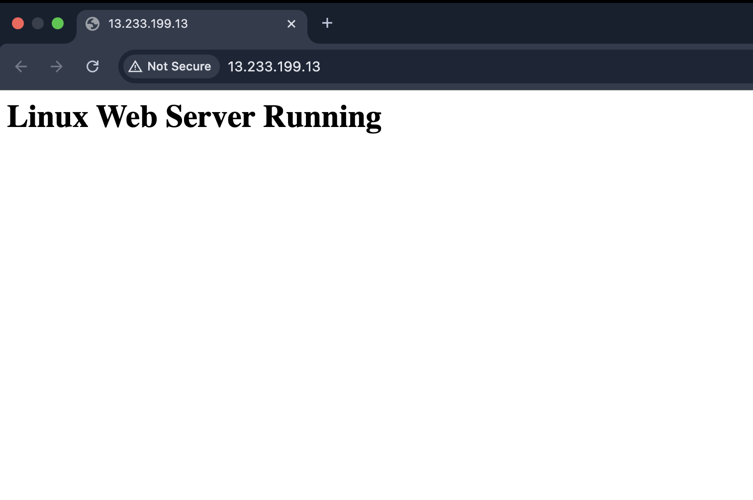

### **Screenshot 3: Windows EC2 Instance Running**

This screenshot shows the Windows EC2 instance launched and in the running state.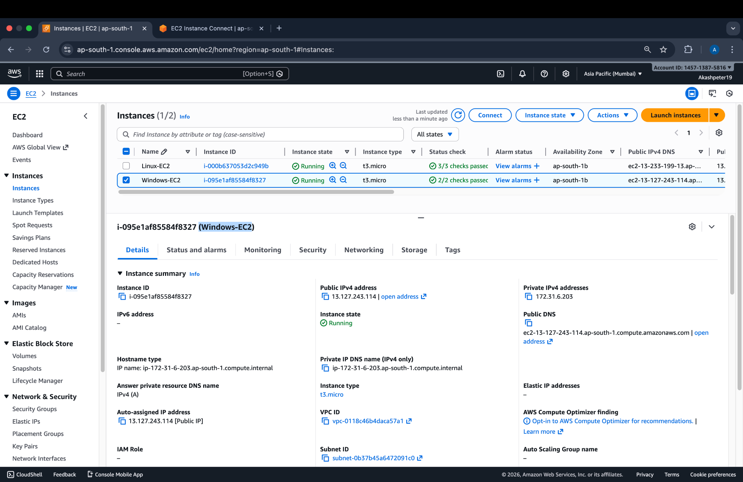

### **Screenshot 4: Windows Web Server Output**

This screenshot confirms the IIS web server is running on the Windows EC2 instance.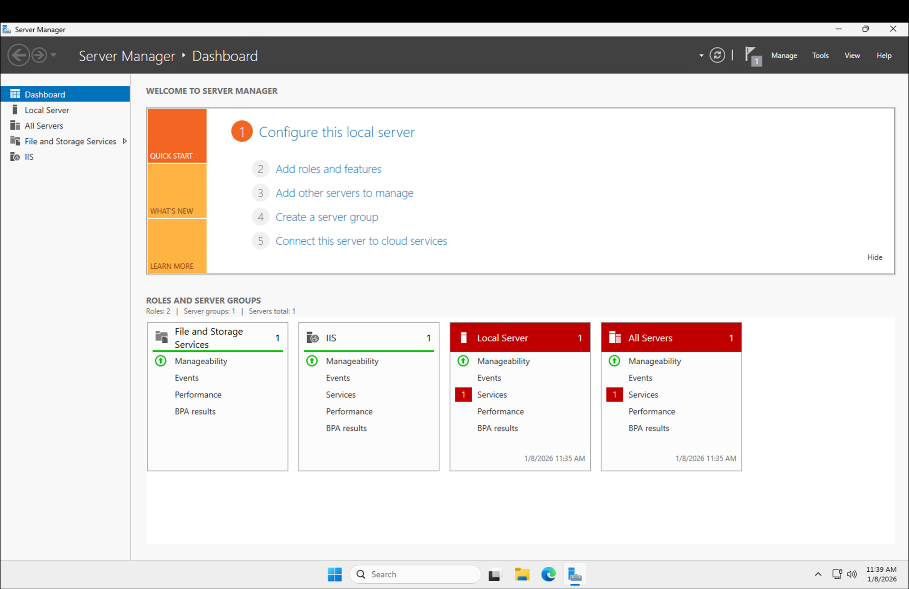

### 

### 

### **Screenshot 5: Creation of 5 GB EBS Volume**

This screenshot shows the creation of a 5 GB EBS volume in AWS.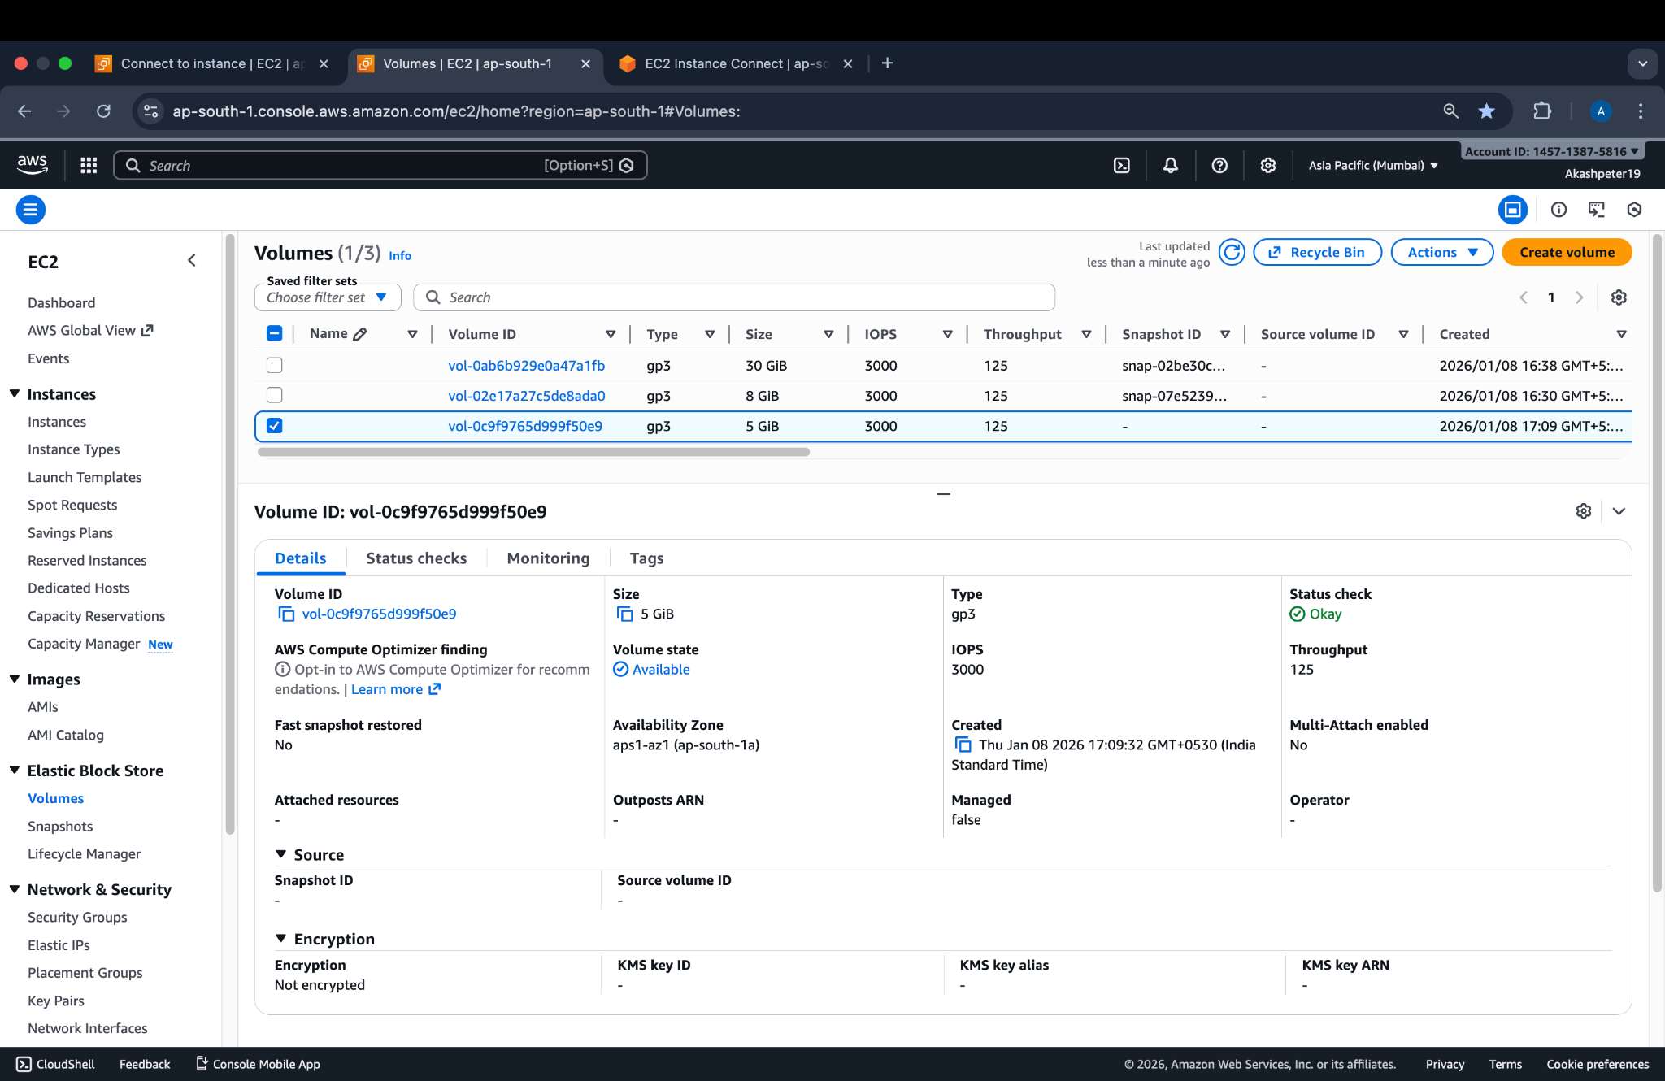

### 

### 

### 

### **Screenshot 6: EBS Volume Attached to EC2 Instance**

This screenshot shows the EBS volume successfully attached to an EC2 instance.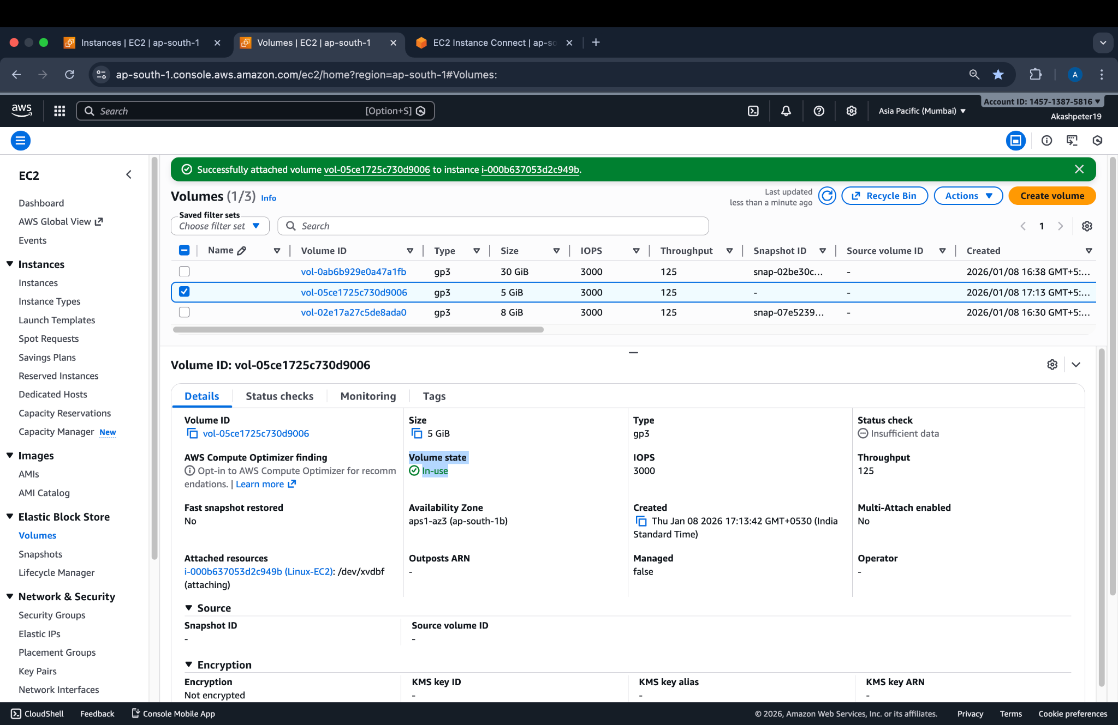

### 

### 

### 

### 

### 

### 

### 

### 

### **Screenshot 7: EBS Snapshot Creation**

This screenshot shows a snapshot being created from the attached EBS volume.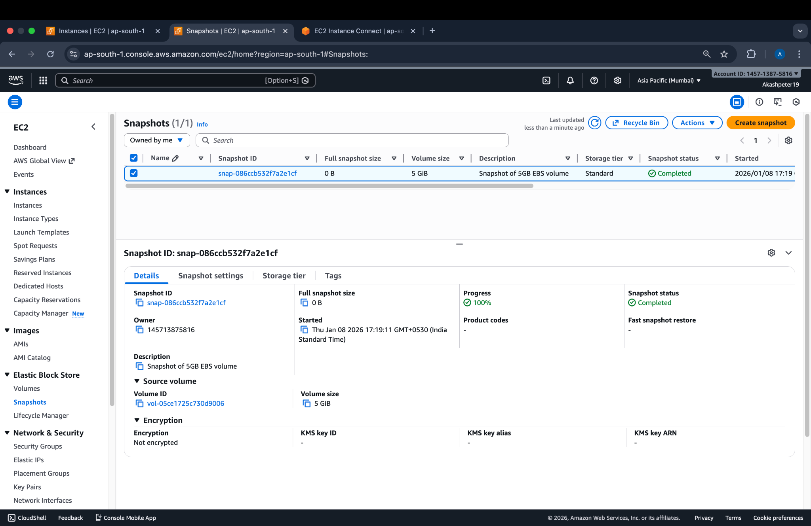

### **Screenshot 8: Snapshot Completion**

This screenshot confirms the snapshot creation has been completed successfully.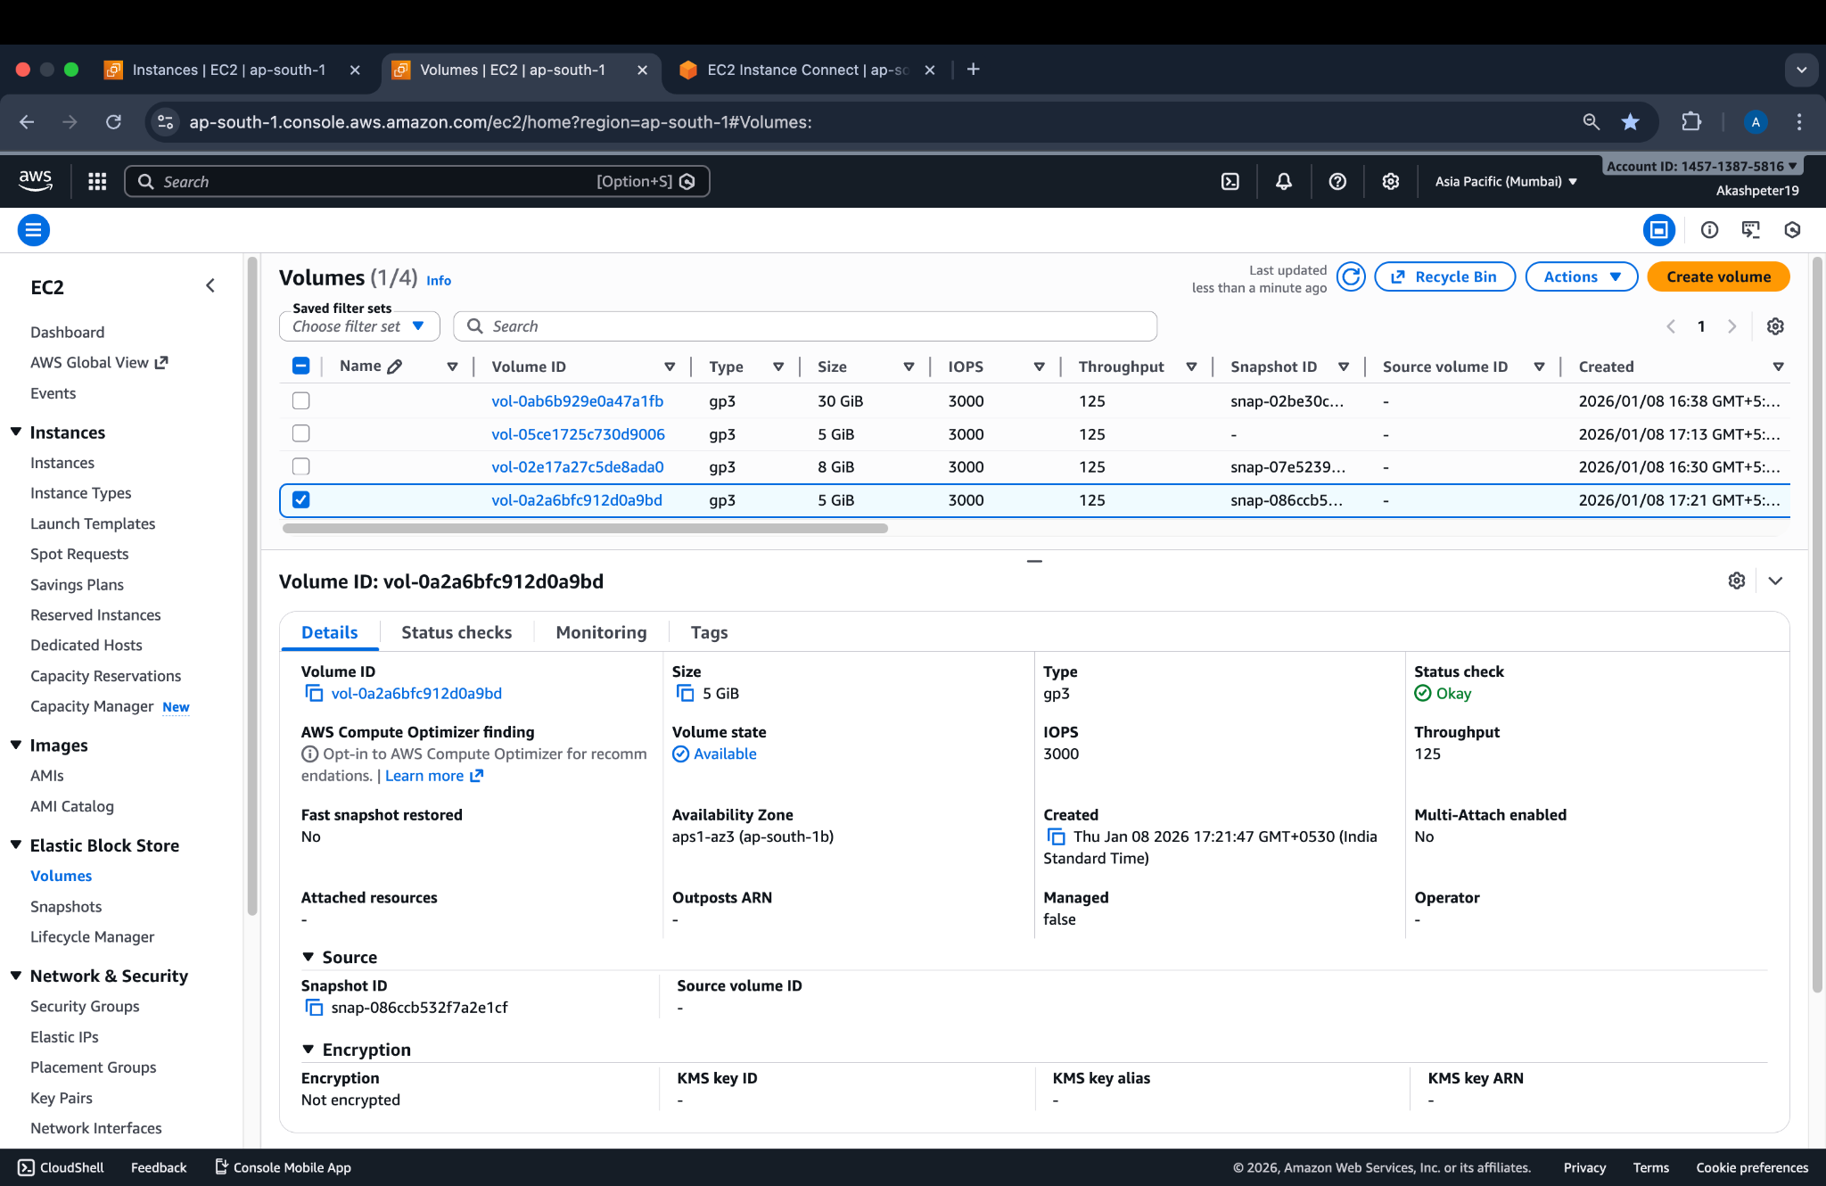

### 

### 

### 

### 

### 

### 

### 

### 

### **Screenshot 9: New EBS Volume Created from Snapshot**

This screenshot shows a new EBS volume created using the snapshot.